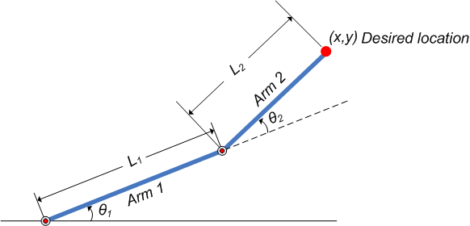

L3

α­­2

α­­1

β

1

α­­